**PROPOSAL REPORT**

**ON THE**

**BOREWELL RESCUE BOT**

**Proposed Work:**

The main aim of the bot is not just just save the child to bring him back safe and sound.

1. **Mechanical Aspect:**

The bot is actuated by a total of 8 actuators. There are 4 major mechanisms of the bot to be noted. The actuators in the bot are controlled via electronic switches on the operators side, Computer Numerical Control (CNC) is incorporated for precise control of the bot. Every actuator position is displayed in a monitor for reference of the operator .

**The 1st actuator (lead screw and jack mechanism) controls the jack head assembly**. It is used to extend and retract the metal pads having the working surface covered with rubber for more grip. As the motor is operated the pad extend and touch the surface of the borewell and secures the bot to the wall of the bore well which provides mechanical stability to the structure. As the structure is sent through tension cables .

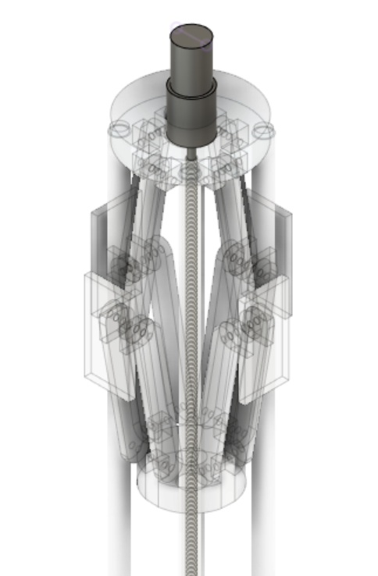

**Figure: Actuator 1**

**The 2nd actuator ( high torque geared motor) is used for rotating the bot.**

Here the actuator uses spur gear on its motor shaft which is meshed with spur gear on the main shaft which rotates the upcoming parts of the bot in z axis. Thus it aids to manoeuvre the bot while rescuing the child.

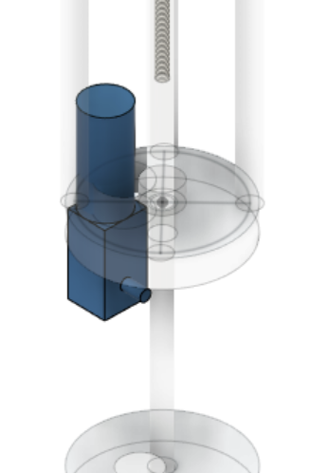

**Figure: Actuator 2**

**The 3rd actuator( high torque geared motor and lead screw mechanism ) is  used to control the vertical position of the cage structure.**

Here the motor shaft is attached to the lead screw and the bolt is connected to the top plate. So upon rotation of motor the top plate can move along the length of the lead screw.

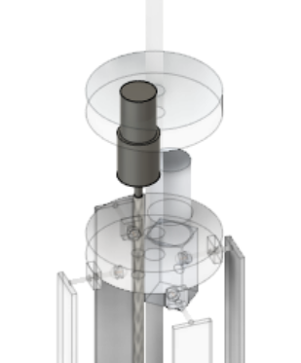

**Figure: Actuator 3**

**The 4th actuator (high torque geared motor and lead screw powered jack mechanism) is used to expand or contract the cage structure.**

The mechanism used here is similar to that of the jack head assembly. This mechanism is used to contract and extend the cage structure this the cage adapts to the size of the borewell.

**The 5th actuator ( 3 slider parallel manipulator powered by high torque geared motor and lead screw) is used to change the position and orientation of the baby catcher.**

This setup is used to give 6 degrees of freedom to the baby catcher hence both the position and orientation of the baby catcher can be controlled precisely hence the baby can be captured with out any problem on the orientation of the child’s head .

**The 6th actuator - ( modular design )**

**1.) motor lead screw jack mechanism is used to open and close the end effector (to catch hands )**

The jack mechanism is used to catch the hands(if the hands is available to be secured or head is secured) , the tip of the end effector is covered with soft material to be gentle on the child’s hand and rubber like material to grab the child tightly.

**2.) vacuum cup mechanism to catch the child in more challenging situations. (to catch head)**

If the child’s hand is not available to catch the jack mechanism can be replaced with a vacuum cup to catch the head and the vacuum cup is powered by a vacuum pump and has tiny pipes with pores though which a slime is pumped out to provide air tight seal to the vacuum cup and the child ’s head.

**The 7th actuator(eccentric vibrator) is used on the cage structure**

This is to provide clearance for cage structure to enter into congested places(between the child ’s body and the wall of the borewell) by providing vibrations up to 10Hz which reduces the friction between the child and the borewell and makes it easy to insert the cage structure between the child and the borewell ’s wall .

**The 8th actuator ( tension pulley powered high torque geared motor ) a part of cage structure.**

The tips of the 3 cage strips are connected to a bag which has cable running through the bag circumferentially and hence the bag can be made to close by tightening the cable , which is done connecting the cable to a tension pulley which rotates and closes the cage structure after insertion beyond the child.

**Main Assembly**

1. **Jack Head Assembly**

This Assembly is what holds or supports the entire structure in place. This is where the first actuation that will take place once the bot reaches the required position.

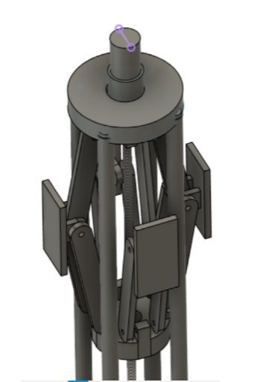

**Figure: Jack Head Assembly**

From the diagram it's evident that when the actuator is turned on, the lead screw attached to the actuator starts to rotate. The lead screw brings the base plate close to the top plate. Now this action would cause the hinge arms to move outwards  and eventually the side plates coated with rubber would be in contact with the walls of the borewell securing the bot in one place.

1. **Baby catcher -**

The position of the child has to be in control, for the rescue operation to be successful. Considering this in mind the gripping mechanism is used to hold a part of the child(hand or head) by the gripper or the vacuum cup so that the further operations can take place smoothly.

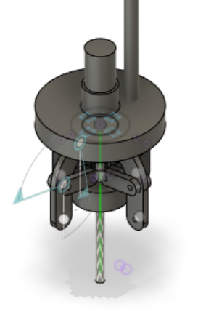

**Figure: Jaw Mechanism**

1. **Cage Structure:**

This structure is used to enclose the child and bring him safely. So once the child's position is noted and the cage structure expands to the maximum(diameter of the borewell) and is sent down along the wall of the borewell eventually covering the child in the four directions with four strips of metal of thickness 3mm and then the bag in the cage structure closes and secures the child firmly.

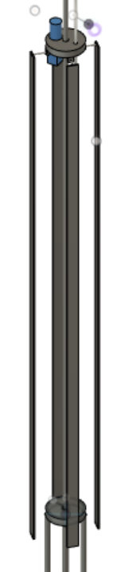

**Figure: Cage Structure**

After this the jack head loosens and the bot is lifted up along with child secured safely.

1. **Electronic Aspect:**

Arduino is used for control of actuation of the bot. The is made to be wireless. The electronics involved in this project are:

**1**.Arduino ( controller)

**2**.HC-12 (to establish wireless communication with ground unit and the bot)

**3**.Relay ( to control motors)

**4**. Gas Sensor(o2)

**5**. pressure Sensor for ( gripper , vacuum cup and jack-head )

**6**. ultrasonic sensor for distance calculation (to find the child's position)

**7**. temperature sensor (to measure ambient temperature)

**8**. infrared camera( to see the child beyond the mud and derbies. And the estimate the child ’s body temperature)

**9**. camera ,led light , mic ,and speaker ( to see the child and speak.(to provide mental assistance).

**10.** inductive proximity sensor.

The bot is controlled wirelessly to make things simple and hence only the power supply wire is sent with bot.

**3.) Working procedure:**

* First the research and oxygen supplier bot with camera, mic, speaker, infrared camera, o2 sensor and temperature sensor is sent to study the bore wells topology and the child ‘s position orientation, health and hence a rescue plan can be made.
* O2 tank supplies oxygen to the child and O2 sensor gives the data in real time.
* The bot is set to get launched on a base structure on the ground of height 3m high
* The Bot is sent into the bore with the help cables and the cables are lowered
* manually by ratchet pulley mechanism and the child ‘s position is found by connecting rotary encoder to the ratchet pulley (while sending the research Bot).
* Now the the main bot is lowered and fixed about 150 mm away from the child ‘s position with the actuator-1 mentioned above now the bot lower part is rotated by actuator-2 mentioned above which rotates the cage structure to get the path of least reactance ( to align though a gap) to make the insertion easier.
* The end effector is aligned both in position and orientation according to position of the child's head or hand by the actuator-5 (parallel manipulator).
* Next process is to catch the child ‘s head with the end effector(actuation -6) , gripper ( if its the hand) or vacuum cup ( if only head is available to catch )
* The cage structure is expanded to the size of the bore well, By the actuator - 4.
* The cage is pushed in between the child by actuator-3 until it moves 30 cm beyond the child measured by CNC control .
* To reduce the frictional force acting on the child due to cage rod a high amplitude low frequency vibrator (actuator-7) is used , which reduce the friction between the child and the cage strips
* Hence the cage can be closed now with the actuator-8. which is confirmed by the inductive proximity sensor.
* And the gripper or the vacuum cup is loosened to avoid applying too much load on head or the hands.
* The top head jack is contracted and the child is lifted up manually by pulling the bot up by the ratchet-pulley mechanism.
* Both the main and the research and oxygen supplier bot is lifted at the same pace hence the child will receive oxygen continuously and the child ’s health data will be contentiously available throughout the lifting operation.
* The lifting is done slow to not panic the child and hence the child will receive very little or no injuries while lifting.
* Hence the child is rescued safely.

**Implementation:**

**Work Plan:**

|  |  |
| --- | --- |
| **Month** | **Work Schedule** |
| **July** | Further Analysis of the prototype (version-1 bot) in simulation and analysis software(ansys and inventor pro) |
| **August** | Doing research on the other available bots for this purpose to get clear idea for the version - 2 |
| **September** | Further research of the bot and planning on the operations and actuations of the version-2 (bot) |
| **October** | Finalizing the operations that the bot has to perform and the actuations to be used to perform them. |
| **November** | Designing the research and oxygen supply bot |
| **December** | Designing the cage structure and head jack for the version-2 |
| **January** | Designing the parallel manipulator for the end effector of the  version -2 |
| **February** | Designing of the other actuators. |
| **March** | Connecting all different assemblies together with a modular design. |
| **April** | Deigning a robust structure to launch the oxygen bot and the rescue bot together. |
| **may** | Basic Coding for the bot starts |
| **June** | Assuming corona is gone  Approaching our university (Anna university-Chennai) and other companies, agencies for sponsorship. |
| **July** | The components needed to build the bot are researched for comparative pricing and Finalized where to buy from  ( assuming we get the required financial support ) |
| **August** | Building of the bot starts and continues for 6 months |
| **March** | Electrical and electronics are incorporated |
| **April** | Adding software codes developed simultaneously |
| **May** | Lab Testing and fine tuning |
| **June** | Lab testing and software tuning |
| **July** | Testing in a borewell with dummy and fine tuning the hardware components |
| **August** | Testing and fine tuning total system and preparing a transportation system to transfer the bot to the site. |

**Expected Outcomes:**

**“ U do da praveen and hariharan in about 300 words is fine da ”**

**Applications:**

* It can be used to rescue child fallen into the bore wells and manholes.
* It can be used to research the borewell and manholes.
* It can be used to rescue stuffs other then child too such as submersible pumps etc
* It can be used to study the underground topology of the area
* Modified version of It can be used to study the oil wells too.

**Conclusion:**

The Proposed system is predominantly intended to save the child with minimal amount of injuries. In the previous 15 years, bunches of lives had been lost by tumbling into the bore well since burrowing a pit adjacent to the drag well is time consuming process. By adapting this system, we can rescue the life of the child within a short span of time. The Robotic arm will pick the belt and fix it to the child appropriately. These robots are lifesaving machines. It can save many lives of the children, so it is very beneficial to use this robot.

**Financial Assistance reason:**

The financial assistance of 3,00,000 Lakh would be useful for us to make the completely functioning bot which will rescue the child fallen into any kind of a borewell or manhole, the prototype of the bot we mentioned above is already made with cheaper material and motors which is one its way to be used for extensive testing and hence on finishing the testing the new bot will be designed in such a way that it is ready to handover to the fire department for saving lives of dozens of children in India . and another version can also be used for other commercial purposes such as oil well surveillance, borewell , with sufficient modifications recovering of abandoned submersible motors in the borewell, Study of the topology of the borewell, and the bot can even be sent into cracks and other holes for surveillance and rescue in the case of earthquakes and land slides .

**Fabrication** **- 1.5l**

**Electronics - 50k**

**Electrical components - 80k**

**Testing - 20k**